Name: Majid Ali
CMS ID: 053-25-0017
Course: Java (Lab: 2)

Exercises
Instructions:
• Solve all tasks using methods only.
• main() should only call methods and print results.
• All methods must be static.
• Focus on logic and clean implementation.

Task 0: Syntax Errors
Broken Code | Find the Error | Fix It
static int add(int a int b){ return a+b; } | Comma is missing | static int add(int a ,int b){ return a+b; }
static void show(){ System.out.println("Hi") } | Semi colon is missing | static void show(){ System.out.println("Hi"); }
static int square(int x){ System.out.println(x*x); } | Return type is missing | static int square(int x){  return x*x;  }
switch(x){ case 1: System.out.println("One") break; } | Semi colon is missing | switch(x){ case 1: System.out.println("One"); break; }
int[] arr = new int[5] | Semi colon is missing at end of array declarartion | int[] arr = new int[5];
public static void main(String args){ } | Aary [] is not given with args | public static void main(String args){ }
static int max(int[] arr){ return arr.length } | At end return semi colon is missing | static int max(int[] arr){ return arr.length;}

Task 1: Smart Number Analyzer
Method Type:
Return: String
Parameters: int n
Return:
• "Positive Even" if number is positive and even
• "Positive Odd" if positive and odd
• "Negative" if number is negative
• "Zero" if number is 0
class Numbers{
public static void main(String args[]){
int x=5;
System.out.println(checkNumber(x));
}
static String checkNumber(int a){
if(a==0){
return "Zero";
}
else if(a>0){
return "Positive";
}
else {
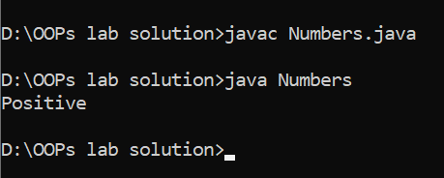
return "Negative";
}
}
}

Task 2: Conditional Calculator
Method Type:
Return: int
Parameters: int a, int b
Rules:
• If a > b, return a − b
• If a < b, return b − a
• If equal, return 0
class Numbers{
public static void main(String args[]){

System.out.println(checkNumber(5,6));
}
static int checkNumber(int a,int b){
if(a>b){
return a-b;
}
else if(a<b){
return a+b;
}
else {
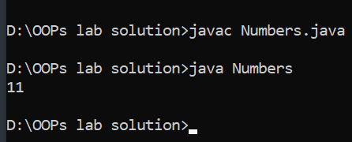
return 0;
}
}
}

Task 3: Array Balance Checker
Method Type:
Return: boolean
Parameters: int[] arr
Return true if sum of even elements equals sum of odd elements.
class Numbers{
public static void main(String args[]){
int arr[]={1,2,3,4,5,6};
System.out.println(checkNumber(arr));
}
static boolean checkNumber(int arr[]){
int sum1=0;
int sum2=0;
for(int i=0; i<arr.length; i++){
if(arr[i]%2==0){
sum1+=arr[i]; }
else {
sum2+=arr[i];
}
}
return sum1==sum2;
}
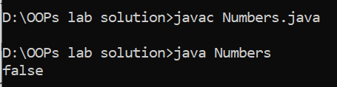
}

Task 4: Switch-Driven Grading System
Method Type:
Return: String
Parameters: int marks
Use switch on (marks / 10):
• 10 → Distinction
• 9 → Excellent
• 8 → Very Good
• Others → Fail
Note: marks are in range (0-100).
import java.util.Scanner;
class Numbers{
public static void main(String args[]){
Scanner input=new Scanner (System.in);
System.out.print("Enter the marks: ");
int marks=input.nextInt();
System.out.println(grade(marks));
}
static String grade(int marks){
switch(marks/10){
case 10:
return "Distinction";
case 9:
return "Excellent";
case 8:
return "Very Good";
default:
return "Fail";
}
}
}
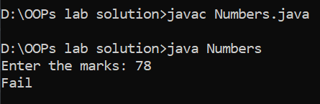

Task 5: String Pattern Validator
Method Type:
Return: boolean
Parameters: String s
Return true if:
• Length ≥ 6
• First character uppercase
• Last character is a digit
import java.util.Scanner;
class Numbers{
public static void main(String args[]){
String s1="hello";
String s2="Hello1";
String s3="hi9";
System.out.println(validate(s1));
System.out.println(validate(s2));
System.out.println(validate(s3));
}
static boolean validate(String s){
if(s.length()<6){
return false;

}
if (!Character.isUpperCase(s.charAt(0))) {
return false;
}

if (!Character.isDigit(s.charAt(s.length() - 1))) {
return false; }
return true;}
}

Task 6: Array Peak Finder
Method Type:
Return: int
Parameters: int[] arr
Return index of the largest element.
If multiple max values exist, return first index.
class Array{
public static void main(String args[]){
int arr[]={1,2,3,4,5};
largestNumber(arr);
}
static void largestNumber(int arr[]){
int max=arr[0];
int index=0;
for(int i=0; i<arr.length; i++){
if(arr[i]>max){
max=arr[i];
index=i;
}
}
System.out.println("Largest number " +max +" present at " +index);
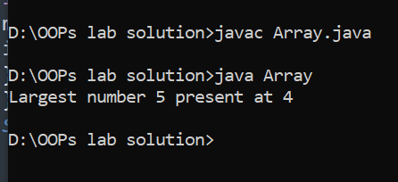
}
}

Task 7: Math-Based Decision Maker
Method Type:
Return: String
Parameters: int a, int b
Return "Perfect Square Difference" if |a − b| is a perfect square.
Otherwise return "Not Perfect Square".
import java.util.Scanner;
class Array {
public static void main(String args[]) {
String result = square();
System.out.println(result);
}
static String square() {
Scanner input=new Scanner(System.in);
System.out.print("Enter a: ");
int a=input.nextInt();
System.out.print("Enter b: ");
int b=input.nextInt();
int diff =Math.abs(a - b);
int sqrt =(int) Math.sqrt(diff);
if (sqrt*sqrt==diff) {
return "Perfect Square";
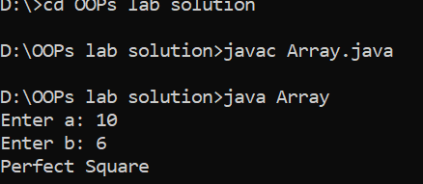
} else {
return "Not Perfect Square";
}
}

Task 8: Command-Line Validator
Method Type:
Return: void
Parameters: String[] args
Accept 3 numbers via command-line and print:
• Largest number
• Smallest number
• Difference between them
class CommandLine {
public static void main(String[] args) {
arguments(args);
}
static void arguments(String[] args) {
if (args.length != 3) {
System.out.println("Please enter exactly 3 command line arguments");
return;
}
int largest = Integer.parseInt(args[0]);
int smallest = Integer.parseInt(args[0]);
for (int i = 0; i < 3; i++) {
int num = Integer.parseInt(args[i]);
if (num > largest) {
largest = num;
}
if (num < smallest) {
smallest = num;
}
}
System.out.println("Largest Number: " + largest);
System.out.println("Smallest Number: " + smallest);
System.out.println("Difference between them: " + (largest - smallest));
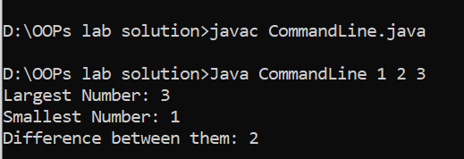
}
}

Task 9: Array Trend Detector
Method Type:
Return: String
Parameters: int[] arr
Return:
• "Increasing" if strictly increasing order in numbers
• "Decreasing" if strictly decreasing order in numbers
• "Mixed" otherwise
class ArrayTrendDetector {

static String detectTrend(int[] arr) {
if (arr.length <= 1) {
return "Mixed";
}

boolean increasing = true;
boolean decreasing = true;

for (int i = 0; i < arr.length - 1; i++) {
if (arr[i] >= arr[i + 1]) {
increasing = false;
}
if (arr[i] <= arr[i + 1]) {
decreasing = false;
}
}

if (increasing) return "Increasing";
if (decreasing) return "Decreasing";
return "Mixed";
}

public static void main(String[] args) {
int[] arr1 = {1, 2, 3, 4};
int[] arr2 = {5, 4, 3, 2};
int[] arr3 = {1, 3, 2, 4};

System.out.println(detectTrend(arr1));
System.out.println(detectTrend(arr2));
System.out.println(detectTrend(arr3));
}
}
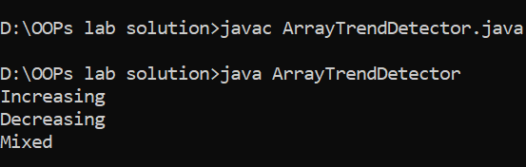

Task 10: Mini Decision Engine
Method Type:
Return: String
Parameters: int n
Return:
• "Prime Even" if n = 2
• "Prime Odd" if prime and odd
• "Composite" if not prime
• "Invalid" if n ≤ 1
import java.util.Scanner;
class PrimeNumbers{
public static void main(String args[]){
prime();

}
static void prime(){
Scanner input=new Scanner(System.in);
System.out.print("Enter the number: ");
int num=input.nextInt();
if(num<=1){
System.out.println("Invalid");
return;
}
boolean isprime=true;
for(int i=2; i<=Math.sqrt(num); i++){
if(num%i==0){
isprime=false;
break;
}
}
if(isprime){
System.out.println("Prime number");
}
else{
System.out.println(" Not Prime number");
}
}
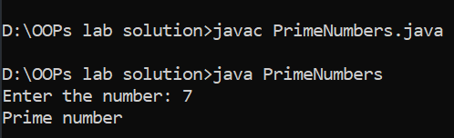
}

Task 11: Debugging Practice
Broken Code | Find the Error | Fix It
int[] a = new int[5]; a[5] = 10; | In array is total size size-1 so it end with less then 5 so how you put number at 5 index | int[] a = new int[5]; a[4] = 10;
int sum; for(int i=0;i<arr.length;i++) sum+=arr[i]; | In this code sum is not assign with 0 | int sum=0; for(int i=0;i<arr.length;i++) sum+=arr[i];
static int max(int[] arr){ int m=0; ... } | In this code m is not assign with arr[0] | static int max(int[] arr){ int m=arr[0]; }
switch(x){ case 1: System.out.println("One"); case 2: ... } | In this code you did not define statement at case 2: | int x = 1;  switch(x){  case 1: System.out.println("One");  case 2: System.out.println("Two");  }
Integer.parseInt(args[0]); | In this code integer into string can not assign with variaable | int a=Integer.parseInt(args[0]);
static void calc(int a,int b){ return a+b; } | Your method is void so you cannot use return | static int calc(int a, int b) {  return a + b;  }
return arr[arr.length]; | Int this code you does not subtract -1 because arr start with 0 | arr[arr.length - 1]
static String day(int d){ switch(d){ case 1: return "Mon"; case 2: return "Tue"; default: "Invalid"; } } | In swith code you don’t use return at end with default | static String day(int d){ switch(d){ case 1: return "Mon"; case 2: return "Tue"; default:  return "Invalid"; } }
static int add(int a,int b){ System.out.println(a+b); } | If use method with int so use return | static int add(int a,int b){ return (a+b); }

